Name: Nehal Patel  
Date: 03/22/2020

1. What is good and bad about RAM as storage for the operating system and data? – 2pts

Answer:

RAM is volatile memory so it’s super-fast compere to Hard disk storage. So, RAM as a storage of operating system it’s make very speedy computer task but if we store everything in RAM there is more chance to crash.

1. As you increase the number of processors by N, is the speedup ratio also N? Why or why not? – 2pts

Answer:

So, no speed ratio is not n due to some overhead tracking information across from the processor. In simple words all process is not running parallel.

1. What could you use a cluster for? – 1pt

Cluster is used for multiple number of systems is working on same tasks. Cluster is also used to provide high-performance computing services. Cluster can work as a single machine.

1. Where would you store a small amount of data, say a 32 bit integer – on the heap or stack? Why? – 1pt

Answer: I would like to use stack because of it’s limited use of small amount of data.

1. Where would you store a large data structure (32MB+) on the heap or stack? Why? – 1pt

Answer: I would like to store in heap because Heap allows user to access all memory virtually and heap is the memory which is requested at run time.

1. Please fill in the blanks that describe the migration of integer A from disk to register (hint-pg 28): - 1pt

**Magnetic disk**

**C?**

**B?**

**A?**

A: Main memory

B: Cache

C: Hardware Register

1. Please write an application (language of your choice but they MUST use system calls) that moves a file (ie implements mv command) in the platform of your choice (Windows or Linux).

Hint 1: I have an example of the cp command that uses system calls in C/C++ for Windows and Linux

Hint 2: unlink for Linux (<http://linux.die.net/man/2/unlink> ) and DeleteFile (<http://msdn.microsoft.com/en-us/library/windows/desktop/aa363915(v=vs.85).aspx> ) for Windows. – 3pts

**PLEASE NOTE – if your code DOES NOT use system calls you will receive a 0 on this assignment.**

1. Please write an API that wraps the code for the cp command such that the function has a prototype of: - 3pts

void cp(const char * src, const char * dst)

Hint 1: It’s simpler than you think

Hint 2: Look at the sample code

**PLEASE NOTE – if your code DOES NOT use system calls you will receive a 0 on this assignment.**

1. What benefits are there to a micro-kernel? What benefits are there to a monolithic kernel? Which would you use and why? -2pts

Answer: micro-kernel provide structure the operating system by removing all non-essential components from kernel. so, it's expanded the operating system. all new service is added to user space, so no modification of kernel required. Monolithic Kernel is useful in memory and file managements and many operating functions using system call. I will use micro-kernel because it’s provided small structure and secure which is good to run simple functions of operating system.

1. At what level ring/layer allows full unrestricted access to the hardware? – 1pt

Answer: 0 level ring or layer allows full unrestricted access to the hardware.

1. Name 3 tools from either Windows or Linux that allow you to inspect system information and state what information they show. – 2pts

Answer: 1. Task Manager –it’s shows all application, process and service is currently running

2. Process monitor – it’s shows file system, thread and process activity in real-time.

3. Performance monitor – it’s shows how our system resource is used. Example: memory and disk use.

Extra credit:

1. In class we discussed two modern ways that people interact with the operating system (CLI/Shell and GUI). Today we interact with these interfaces, usually, with a keyboard and mouse. What other way(s) could one interact with the operating system? (Hint: It’s currently being researched/developed and Microsoft has their own concept(s):

<http://www.youtube.com/watch?v=a6cNdhOKwi0> ) – 2pts

1. In the git repo I provide sample code from MikeOS (<http://mikeos.sourceforge.net/write-your-own-os.html> ). After you use the provided scripts to download the necessary tools to work with this code, the assignment is to see if you can add some color to the output. ie turn this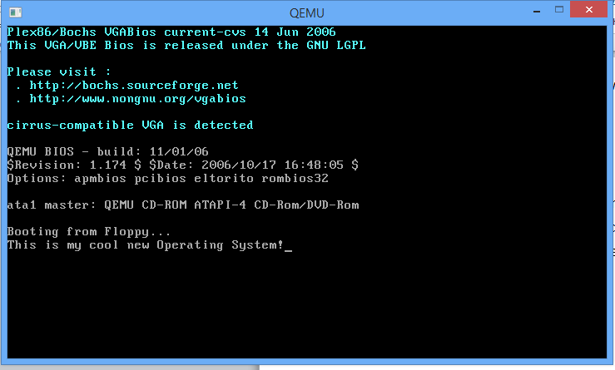  
   To this (be creative!): - 4pts 